**Introduction**

Lake Joondalup lies within the Yellagonga Catchment Area, the catchment lies on the Swan Coastal Plain and is located approximately 20 km north of central Perth. The Proposed project is a bridge over the Joondalup Lake linking Joondalup and Wanneroo together. The bridges purpose is to provide a crossover between Joondalup and Wanneroo and is to provide a quicker route to get between the 2 suburbs and is an alternative route.

**Variables**

Independent: The bridge

Dependant: The 2 dependant variables we’re measuring are the Salinity (ms/cm) and the Turbidity (NTUs) of the water

Controlled: The 3 controlled variables are the water (Which will be tested to make sure it doesn’t change), The location of the bridge and the time the lights are on

Results:

**:** Macroinvertebrate species diversity, abundance and pollution tolerance levels during sampling years.

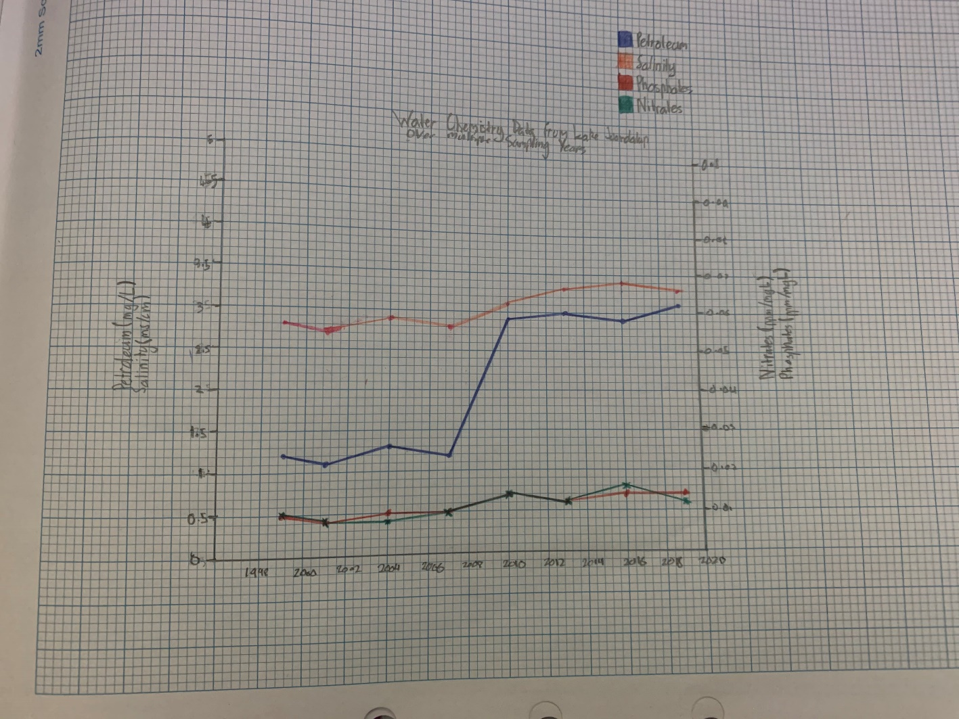

**Table 1**

**Table 2**

**Analysis:** A trend in table 1 is that the Nitrates and Phosphates are basically identical. A trend in table 2 is that the higher the turbidity, the lower the pH. The species went down over time and this is shown in the Macroinvertebrate graph where majority of the species became extinct in 2010 and slowly started to become more popular.

Some potential impacts are that as the bridge is constructed, the closer it gets to finishing, the more land is going to be used therefore taking away the habitats of some of the animals. The noise may potentially frighten the animals as well which could lead them to be disrupted from their usual activities. The positives of the bridge being built are that its another route for the humans to get between Wanneroo and Joondalup, but the negatives are that the bridge is removing the habitats of some of the animals, and it’s going to take a while to construct.

**Reliability and Validity:** The data measured is reliable and valid because it was measured over a long period of time giving us a larger diversity in the results. The bridge is a false Object and isn’t going to be put in the Lake Joondalup lake.

**Mitigation:** Some rules that should be followed are that the lights are allowed to be on between 8pm and 5am to minimise the amount of electricity being used, and because if the lights are bright, it minimises the risk of blinding the drivers. A strategy to minimise the risk and harm of the ecosystem is to try and take out as little bushland as possible as that minimises the risk of taking out the habitats of some animals.

**Evaluation:** Some limitations of the experiment are that there was little to no background information on the Lake Joondalup Site to see whether could stay there. An improvement could be that with the Species Abundance and Diversity, instead of it being tested every 3 years, it could be tested every year or 2 years.

**Conclusion:** In conclusion I can see that after 2010 lots of the animals started to go missing or extinct, If I was the person who would approve or disapprove it I would disapprove it because it’s just not needed as there is already a way to get between the 2 suburbs. This is justified by the high petroleum levels In the water currently, and if there was a bridge with cars going across it, that would mean that most certainly the petroleum level would increase and could potentially kill the ecosystem.